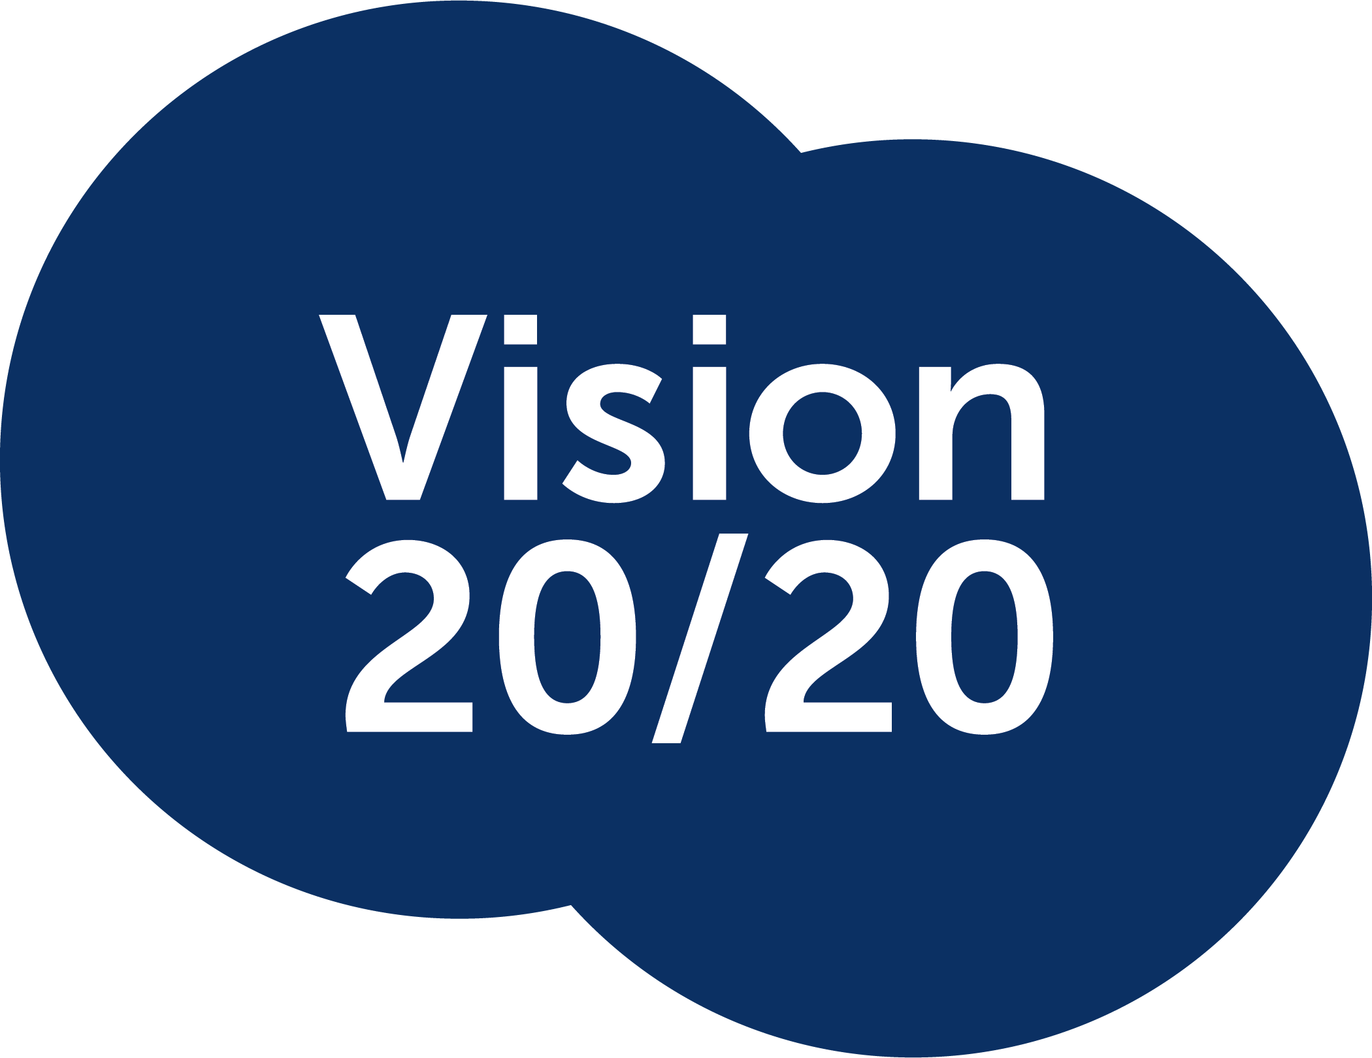

Submission to the Attorney General’s Department
  - Privacy Reform: Consultation on Exposure Draft Legislation

  - September 2026

Contents

Introduction 2
Key principles 2
Existing legal protections 2
Fair and reasonable handling of personal information 3
Privacy-by-design and technology safeguards 3
Differentiating between uses 3
Next Steps 3

Introduction
Vision 2020 welcomes the opportunity to provide feedback on the Privacy Reform Consultation Paper.
Our submission has been informed by input from across our 50 member organisations, collectively representing expertise in eye health, service delivery, research and consumer advocacy. We particularly acknowledge input from Beyond Blindness, Blind Citizens Australia, EssilorLuxottica, Guide Dogs NSW/ACT, and Vision Australia.
Our members support strong privacy protections and recognise legitimate community concerns about the misuse of technologies capable of discreet recording. People who are blind or have low vision share the objective of ensuring that individuals feel safe, respected and protected.
At the same time, surveillance should not be viewed as the primary or sole use case for smart glasses and other wearable technologies. For people who are blind or have low vision, such devices can function as assistive technology, enabling access to information that would otherwise be unavailable. They have the potential to improve safety, independence, education, workplace access, and community inclusion. As these technologies mature, they may significantly reduce barriers to participation and increase the capacity of people with disability to contribute economically and socially. We believe new privacy protections should not restrict accessibility and inclusion.

Key principles
Any future reforms relating to wearable technologies should:
- Focus on regulating the risk of harm to individuals, rather than the use or availability of particular technology.
- Be consistent. The same rules and principles should apply to all devices capable of capturing images and personal conversations, including smart phones and watches.
- Build privacy protections into technology without designing out accessibility.
- Ensure reform protects both privacy and equitable access to information.
- Adopt purpose and risk-based regulation, distinguishing accessibility processing from deliberate recording, retention, facial identification, livestreaming and publication.
- Assess the accessibility impacts of proposed privacy reforms in consultation with people with disability and disability representative organisations.

Existing legal protections
The consultation paper notes that the statutory tort for serious invasions of privacy that commenced in June 2025 is intended to provide redress for serious privacy harms arising from emerging technologies. The tort is designed to be technology-neutral and may apply to both individuals and corporations.
Vision 2020 supports the Government's recognition that existing legal protections are already available to address serious privacy harms. Before considering additional restrictions targeted at wearable technologies, policymakers should carefully examine whether existing protections, including the statutory tort hinged on “serious harm” and the broader Privacy Act framework, are sufficient to address the risks raised by wearable technology. Additional regulation should be developed only where there is clear evidence of regulatory gaps.
We also encourage the development of guidance to support public understanding of how the statutory tort may apply in the context of wearable technologies, including examples that distinguish harmful surveillance from legitimate accessibility uses.

Fair and reasonable handling of personal information
Vision 2020 considers the proposed "fair and reasonable" test to be an important mechanism for balancing privacy and accessibility. The proposed framework requires consideration of a range of factors, including reasonable expectations, genuine choice, proportionality, risk of harm and the benefits flowing from information handling.
Functions relied upon by people who are blind or have low vision often depend on the technology giving environmental information. For example, smart glasses may be asked to describe obstacles, read signs, or locate entrances or exits to premises. In doing so, they may incidentally capture information relating to other people.
We assert that this use, and the use of smart glasses by the ordinary user, is not equivalent to surveillance. The benefits of assisting a blind or low vision person to navigate safely and access information should form part of any proportionality assessment. Regulators should explicitly recognise that accessibility benefits must be considered when determining whether information handling is fair and reasonable.
Regulators should also recognise that technology that features a recording indicator effectively alerts people to the operation of the device, If the recorded subject was able to recognise the recording indicator, but does not object to the use of the device, then there is a reasonable expectation that the recorded subject fairly and reasonably expects that their image and other personal information may have been captured.

Privacy-by-design and technology safeguards
Privacy protections should be concentrated on what happens to information after it is captured rather than restricting the use of and/or access to the technology.
Vision 2020 advocates for an approach that places responsibility on manufacturers and technology providers to implement privacy-by-design safeguards. These could include:
- unmistakable recording indicators which cannot be disabled or easily obscured;
- Minimising storage of images, audio and other information;
- Favouring on-device processing where practicable;
- Limiting transmission of information to third parties; and
- Designing systems that collect only the information necessary to provide the accessibility functions.
This approach directly addresses privacy risks while preserving the benefits of assistive technology.
we also recognise the importance of recording indicators as a way to clarify how smart glasses are being used. This is relevant not only to users who are blind or have low vision, but also to those who choose to install prescription lenses in their smart glasses and may routinely wear them while only occasionally accessing their features. Mandatory recording indicators would reduce the risk that users are incorrectly assumed to be recording simply because they are wearing camera-equipped glasses.

Differentiating between uses
Future regulation should distinguish between use cases for visual and facial information according to their actual privacy risk.
For example, identifying an unknown person through a large-scale facial recognition database raises substantially different privacy concerns from recognising a person the user has deliberately added to a personal contact list.
Treating these functions the same needlessly restricts low-risk accessibility uses without privacy benefits.

Next Steps
Vision 2020 supports strong privacy protections and recognises the importance of addressing harmful uses of emerging technologies. However, privacy reform should not unintentionally limit the ordinary user, and the capacity of people who are blind or have low vision to access information, participate independently and engage fully in community life.
Reforms to the Privacy Act should focus on regulating harmful data practices and high-risk uses of technology, while ensuring that accessibility, independence and participation remain central considerations in the development of Australia's privacy framework.
Vision 2020 and our members must be included in working with the Department through further development of the legislation, and accompanying guidance, to ensure a future where both privacy and accessibility are protected.

