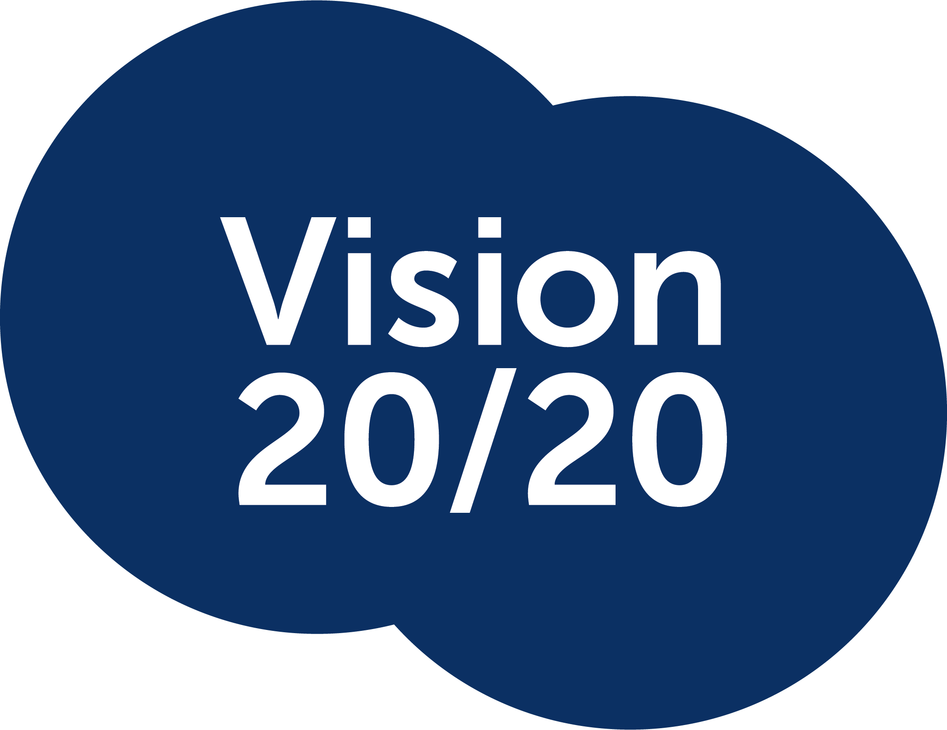

VISION 2020 DIRECTOR NOMINATION FORM
Name: (please print full name and title)
Position:
Organisation:
Nominator (Name & Member Organisation):
Seconder (Name & Member Organisation):
Signatures of Nominator and Seconder:

Qualifications & Experience Statement
The Statement should be no less than 100 words and no more than 500 words. A CV can be attached:

The closing date/time for nominations no later than 12pm AEDST on Wednesday 28 October 2026.
Please scan and email to: Jess Harris-Curley, Operations Manager
jess@v2020.org.au

Nomination Consent

I, (insert name) consent to be nominated as a Director in accordance with the terms set out under the Vision 2020 The Right to Sight Australia Constitution.

I notify you that; my full name is: (insert name)
My date and place of birth is: (insert date of birth)
My usual residential address is: (insert residential address)
My other directorships held are: (insert directorship information)
My telephone contact details are: (insert phone number)
Title: (insert job title)
Member organisation if applicable: (insert organisation name)
Date: (insert todays date)

Signature of Nominee: (insert signature).

